2 sheets of 9 x 12 paper
1 sheets of 12 x 18 chipboard
Tempera paint
Glue – white glue and hot glue
Masking tape

Students will complete 2 paintings using tempera paints – paintings will be painted “landscape” orientation. On the back of each painting, mark the top. Measure across the painting, making a mark every 1½” along the top and bottom edges. Connect the lines for cutting. Before cutting, number the strips on one painting with odd numbers (1, 3, 5,7 ,9, etc.), and number the strips on the other painting with even numbers (2, 4, 6, 8, 10, etc.)

1
1 3 5 7 9 11 13 15
2 4 6 8 10 12 14 16

Cut the paintings into strips. Put the strips into number order (this will alternate strips from each painting. Tape the strips together all along the long edges, making sure to butt the edges exactly. Trim excess tape. When you’re finished, you should have a long painting that measure 9” tall and 24” long.
1
1
1 2 3 4 5 6 7 8 9 10 11 12 13 14 15 16

Accordion pleat the painting along the strips.

Create the mount: Cut the chipboard into 16 strips that measure 8 ½ x 1 ½”. Also cut 8 small pieces that measure 1 ½” square. Tape the strips together in pairs, with long edges butted together. You will have 8 pairs. Flip the pairs over so the tape is underneath, then tape the pairs together. You should be able to easily fold this into an accordion fold.

Cut the squares in half diagonally. Hot glue the triangles into the back of the peaks, one near the top, and one near the bottom. The mounting board will be a little flexible.
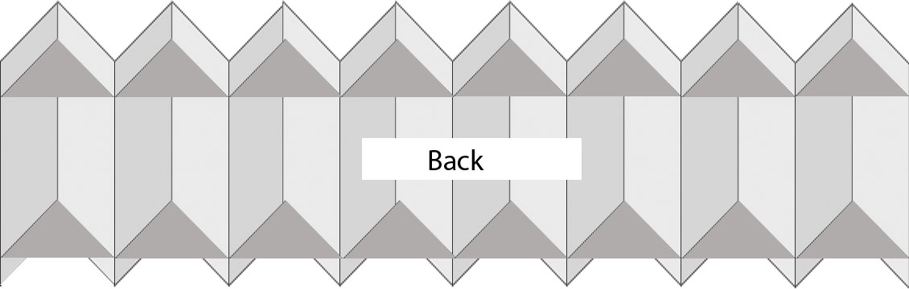

To attach the accordion folded painting to the mounting board, use white glue along the peaks of each fold only. Then glue the two end pieces securely to the mount ends. You can punch holes in two of the triangles on the top of the mount, threading string to hang.

When mounted this way, the two images are viewable as an abstract image from the front view. When moving to either the left or right side, you will be able to see each painting in it’s entirety.

